INFORMATION FOR PRIMARY PARENTS

CHILDNET RESOURCES AND WEBSITES

Childnet: The Hot Topics section contains detailed information on a range of e-safety topics such as downloading, sexting, social networking, gaming and grooming. www.childnet.com

UK Safer Internet Centre: Childnet is part of the European Commission appointed UK Safer Internet Centre. Together with partners the Internet Watch Foundation and the South West Grid for Learning, we raise awareness about internet safety, develop information materials and resources and organise high profile events such as Safer Internet Day. You can access a range of resources from across the UK, Europe and wider afield at www.saferinternet.org.uk.

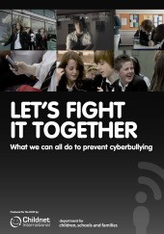Digizen: A website providing information and advice to encourage responsible digital citizenship. It shares advice and guidance on preventing and responding to cyberbullying, including the film ‘Let’s Fight It Together’ and specific information on social networking. www.digizen.org

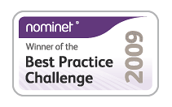KidSMART: This award winning Childnet website is for children, teachers, parents and carers and offers fun games and activities for children alongside effective internet safety advice. Don’t forget to check out our new Early Surfers’ Zone for 3-7 year olds where you can read the online stories ‘The Adventures of Smartie the Pen- guin’ and ‘Digiduck’s Big Decision.’ www.kidsmart.org.uk

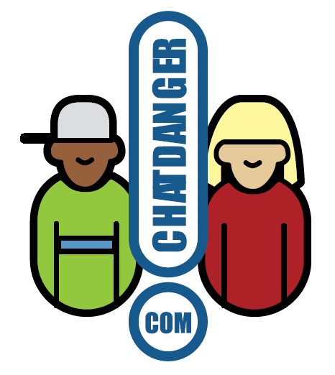Chatdanger: A site for teenagers that shares advice on how to stay safe while chatting online; it gives real life accounts and highlights the potential dangers on interactive services like chat, IM, online games, email and mobiles. Young people can also write to the website for specific advice on different online situations. www.chatdanger.com

OTHER RESOURCES, ACTIVITIES & LESSON PLANS

Think U Know: A website run by CEOP that contains information for children, parents and teachers, as well as a link for children to report abuse online.
www.thinkuknow.co.uk

Digital Literacy and Citizenship: A free set of curriculum documents to support digital literacy and citizenship teaching in school. The documents include medium term plans, individual lesson plans and links to online resources and activities. www.swgfl.org.uk/digitalliteracy

Mini Mentors: Part of the Cyber Mentors programme, encouraging primary pupils to look after themselves and show respect to others through a training programme. www.cybermentors.org.uk/teachers-and-professionals/resources/

Horrible Histories: The BBC created a number of e-safety videos for Safer Internet Day 2012. They are free to view online and can provide a good introduction to a lesson or class discussion. www.bbc.co.uk/cbbc/topics/stay-safe

TES Teaching Resources: The TES website has an extensive resource bank for all subjects, including e-safety. Resources and lesson plans have been created and shared by teachers.
(Sign up required) www.tes.co.uk/teaching-resources/

SOCIAL NETWORKING
Young People & Social Networking Sites: Aims to help parents understand the positive and creative ways young people are using social networking spaces (eg Facebook, Twitter and Google+). It also points out the potential risks of using these sites and ways to minimise these risks.
www.childnet.com/ufiles/Young-people-and-social-networking-A.pdf

Facebook Family Safety Centre: Provides useful information and tips for parents and carers, teens and educators. These pages do not require a Facebook account in order to view them. www.facebook.com/safety

Google+ Safety Centre: Provides useful information and tips for parents and carers, teens and educators. These pages do not require a Google account in order to view them. www.google.com/+/safety

Twitter Help Centre - Tips for Teachers: Provides useful information and tips for teachers and professionals. These pages do not require a Twitter account in order to view them. support.twitter.com

SEARCH ENGINES SUITABLE FOR USE IN SCHOOLS

BBC: www.bbc.co.uk/cbbc/find
Safe Search: primaryschoolict.com

Ask Kids: www.askkids.com
Yahoo!: kids.yahoo.com

WHERE TO GO FOR HELP
Need help? Advice about how to report concerns such as cyberbullying, inappropriate content or illegal behaviour.
www.childnet.com/teachers-and-professionals/for-working-with-young-people/need-help
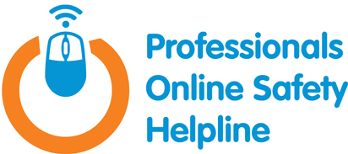Professionals Online Safety Helpline: The UK Safer Internet Centre has been funded by the European Commission to provide a Helpline for professionals who work with children and young people in the UK, specifically tackling the area of e-safety. 0844 381 4772
Child Exploitation and Online Protection (CEOP): A police agency tackling child abuse on the internet. This website includes a unique facility that enables parents and young people to make reports of actual or attempted abuse online. www.ceop.police.uk

Internet Watch Foundation: The UK’s hotline for reporting illegal content found on the internet. It deals specifically with child abuse and criminally obscene images hosted in the UK and internationally. www.iwf.org.uk

Find us on Facebook:
childnetinternational
Follow us:
@childnet
Subscribe to our newsletter to stay up to date:
www.childnet.com

